# INSIGHTSTREAM: NAVIGATE THE NEWS LANDSCAPE

**1.INTRODUCTION:**

Navigating the news landscape involves understanding its transformation from traditional media to a digital-first ecosystem, characterized by rapid technological shifts, information overload, and the rise of social media and user-generated content. Key aspects include fostering media literacy to discern truth from misinformation, embracing innovation and new platforms, adapting journalistic practices to meet changing audience expectations, and maintaining ethical standards to build trust and credibility in a complex, dynamic environment.

**Project title** : InsightStream: Navigate the News Landscape

**Team id:** NM2025TMID48796

**Team Leader** : Liketha.J

**Mail Id** : [likethajalapathi@gmail.com](mailto:likethajalapathi@gmail.com)

**2.PROJECT OVERVIEW:**

**Purpose:**

A project overview titled "Navigate the News Landscape" focuses on understanding the modern media environment by examining how news is created, distributed, and consumed across various platforms, with the primary purpose being to equip participants with the skills to critically assess information, identify misinformation, and foster media literacy. The purpose is to help individuals and journalists navigate the complexities of the digital age, address challenges like declining trust and misinformation, and identify

**Features:**

Navigating the news landscape involves using strategies like verifying information across multiple sources, understanding different media types and platforms, recognizing the influence of personalized algorithms and push notifications, and developing critical media literacy skills to identify misinformation and understand complex issues. A multi-faceted approach combining educational strategies, technological tools, and collaborative efforts is essential for staying informed in a complex, evolving media environment.

**3.ARCHITECTURE**:

To "navigate the news landscape of architecture" means to understand and stay informed about the news and trends in architecture and landscape architecture, particularly through professional organizations like the American Society of Landscape Architects (ASLA) and publications, and to consider how social media impacts architecture news and design communication. It also involves engaging with the multifaceted field of landscape architecture, which combines science and design to create healthy and sustainable outdoor spaces, and understanding how this profession addresses modern issues like climate change.

**Key Aspects of the Landscape Architecture News Landscap**e

**Specialized Media:**

Websites and platforms like World Landscape Architecture (WLA) focus on news and trends in the landscape architecture field.

**Academic & Student News:**

Universities often report on their students' and faculty's achievements in landscape architecture, as seen with the UF College of Design, Construction and Planning reporting on top honors in design competitions.

**Ethical Considerations of Social Media**:

The rise of social media has introduced new challenges for architectural journalism, affecting how news is disseminated and potentially blurring the lines between professional journalism and user-generated content.

**4.SETUP INSTRUCTIONS**

**1. Prerequisites:**

Node.js

Mongodb

Git

React.js

Express.js-Mongoose-visual Studio code

To navigate the modern news landscape, focus on understanding its digital nature by embracing new technologies and platforms, leveraging data analytics, and developing personalized content strategies. Crucially, cultivate strong media relationships, maintain authenticity and transparency, and actively engage with communities to foster trust and build a resilient information ecosystem. Finally, stay adaptable by continuously monitoring trends and investing in emerging technologies to remain effective in a constantly evolving environment.

**Strategies for Navigating the News Landscape:**

**Embrace Digital Transformation**:

Integrate new digital platforms, video, and social media into existing workflows and content creation processes to reach audiences effectively.

**Leverage Data Analytics:**

Use data to understand audience needs, measure the impact of content, and inform strategic decisions to create more personalized and engaging news experiences.

**Personalize Content:**

Tailor news delivery and content to individual preferences and interests to build deeper connections with audiences.

**Build Strong Relationships:**

Foster genuine connections with other media outlets, journalists, and sources to enhance visibility, collaboration, and mutual support.

**Prioritize Authenticity and Transparency**:

Focus on accurate, verifiable information and clearly distinguish between news and opinion to rebuild and maintain trust with the public.

**5.FOLDER STRUCTURE** :

To "navigate the news landscape folder structure," you should use a structured approach by organizing digital files into logical, hierarchical folders based on a chosen system like the Johnny Decimal System or by employing taxonomy and faceted navigation to categorize news topics. A well-defined structure makes it easier to find information, whether you are a digital-native consumer or a developer building a news application.

**6.RUNNING THE APPLICATION**:

"Navigate the news landscape running the application," understand the app's features like personalization and search, identify key sections (e.g., headlines, for you), and utilize tools for filtering and organizing news to match user preferences and stay informed across a complex media ecosystem.

**1.Understand the Application's Features :**

**Personalization:**

Many news applications offer personalized feeds, allowing users to customize the content they see based on their interests and favoured news sources.

**Search Functionality**:

Use the application's search feature to find specific topics, keywords, or events, helping to cut through the vast amount of information available.

**Filtering and Categorization**:

Look for options to filter news by category (e.g., politics, sports, technology) or by specific news outlets to focus on what matters most to you.

2.Explore Key Sections

**Headlines:**

This section typically provides a curated overview of the most important current news, giving you a quick update on major events

**7.API DOCUMENTATION**

News API is a simple HTTP REST API for searching and retrieving live articles from all over the web. It can help you answer questions like:

What top stories is TechCrunch running right now?

What new articles were published about the next iPhone today?

Has my company or product been mentioned or reviewed by any blogs recently?

You can search for articles with any combination of the following criteria

Keyword or phrase. Eg: find all articles containing the word 'Microsoft'

**8.API DOCUMENTATION**:

To navigate the news landscape and ensure authentic information, you must develop strong digital literacy by verifying facts, cross-checking sources, and being critical of online content, especially on social media platforms where misinformation and deepfakes are prevalent. As news consumers, recognize that trust is fragile, and be aware of the proliferation of misinformation and cybersecurity threats that erode credibility. For news producers, authenticity, transparency, and understanding audience needs are crucial for building trust.

**Strategies for News Consumers**

**Verify and Fact-Check:**

Use fact-checking resources to confirm claims and cross-reference information with multiple credible sources.

**Be Critical of Sources**:

Don't accept information at face value, especially on social media, where misinformation and disinformation are easily spread.

**Understand Bias:**

Be aware that news sources may have biases, and seek out a variety of perspectives to get a balanced view.

**Recognize Misinformation Tactics:**

Learn to identify techniques used to spread false information, such as deepfakes, which can present fabricated videos as real.

**Stay Informed About Digital Threats:**

Be aware of cybersecurity threats like phishing and token theft, which can lead to data breaches and further erode trust. Strategies for News Producers

**Prioritize Authenticity and Transparency:**

Share genuine stories and maintain clear, honest communication, especially during significant events, to build reader trust

**Adapt to the Digital Landscape:**

Stay informed about new technologies and platforms to adapt to the evolving need of online audiences and remain relevant. Stay informed about new technologies and platforms to adapt to the evolving needs of online audiences and remain relevant.

**9.USER INTERFACE**

To "navigate the news landscape user interface" means to effectively find, filter, and understand information within the modern digital environment of news and media. Key strategies include using multiple reputable sources to combat bias, recognizing the inverted pyramid structure in news articles, diversifying news consumption beyond social media, and staying aware of how technology like AI and data visualization is shaping news delivery.

**Understanding the Modern News Landscape:**

**Digital First Focus**

The traditional print media model is declining, with news organizations increasingly relying on digital platforms like social media, websites, and apps to reach audiences.

**Information Overload:**

The sheer volume of information available online can be overwhelming, making it challenging to distinguish between credible news and misinformation. Strategies for Effective Navigation

**1.Diversify Your Sources:**

To get a more accurate picture of events, avoid relying on a single publication and read from various sources with different perspectives to prevent confirmation bias.

**2.Look for Reputable Sources:**

Prioritize well-known news organizations that provide comprehensive coverage and factual reporting.

**3.Understand News Structure**:

Most news articles follow the "inverted pyramid" structure, which places the most important information (the lead) first, followed by supporting details.

**4.Beyond Social Media:**

While social media offers fast news delivery, news consumers should also utilize traditional news outlets and apps for in-depth reporting and verification.

**10.TESTING :**

To navigate the modern news landscape, journalists must test content for accuracy, audience engagement, and ethical standards, using data to understand audience preferences and AI tools to enhance verification and story generation. Testing should involve rigorous fact checking, monitoring public reaction to gauge impact, and identifying bias in coverage. Strategies include utilizing audience analytics, staying informed on emerging technologies like AI, and developing sensitivity to the evolving demands of media consumption in a digital-first environment. For Journalists & Newsrooms.

**Test Content for Engagement & Impact**:

Use analytics to track user engagement, sentiment, and how different story formats perform with your audience.

**Leverage Data for Strategic Planning:**

Conduct market research to identify trending topics and audience interests, which can inform content creation and position you as a thought leader.

**Integrate AI Tools:**

Explore AI for efficient data analysis, topic discovery, and even generating story drafts or headlines, but always prioritize human oversight for accuracy and ethics.

**Employ Rigorous Fact-Checking:**

Implement processes using advanced tools to verify text, images, and video content to combat misinformation and maintain credibility.

**Understand Your Audience's Digital Behavior:**

Monitor social media and online conversations to understand what topics reporters are covering and how the audience is responding to them.

**Diversify Your Content Mix:**

Combine quantitative and qualitative data to build hypotheses, test ideas, and provide deeper insights in your content. For News Consumers:

**Be a Critical Reader:**

Read carefully, understand the main points, and use a dictionary for unfamiliar terms.

**Understand Bias:**

Be aware of potential bias, especially in commercial media, which can favor specific political or economic interests.

**11.SCREENSHOTS OR DEMO**

**Powershell->Run as administrator=> set-executionPolicy unrestricted->Press Enter**

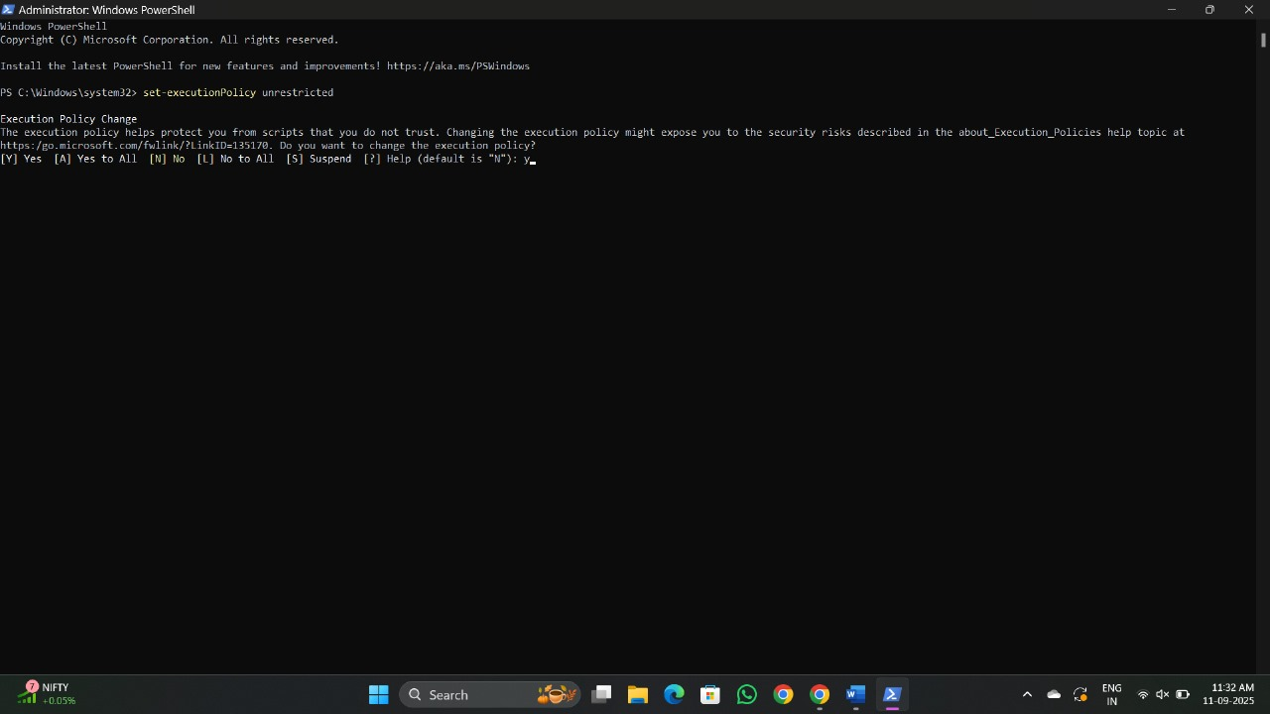

Open Microsoft Visual Studio Code-> Open Folder->App.js

Run new terminal->npm install

Npm start

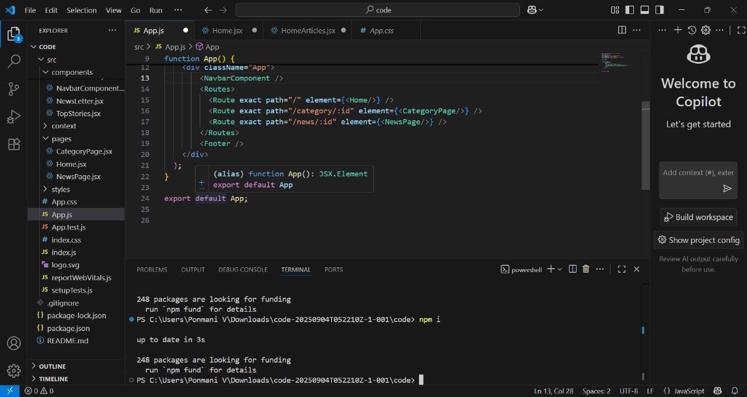



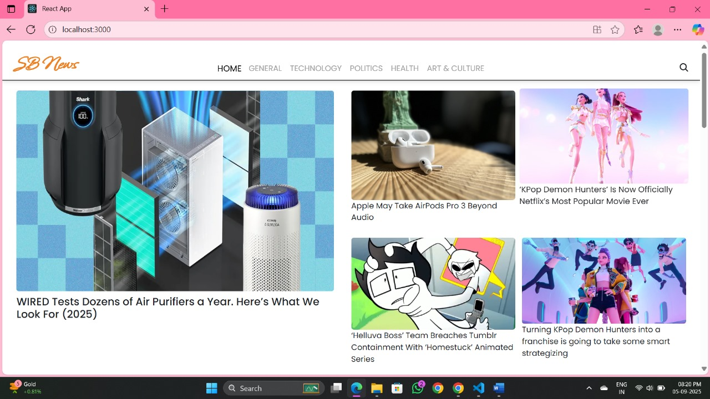

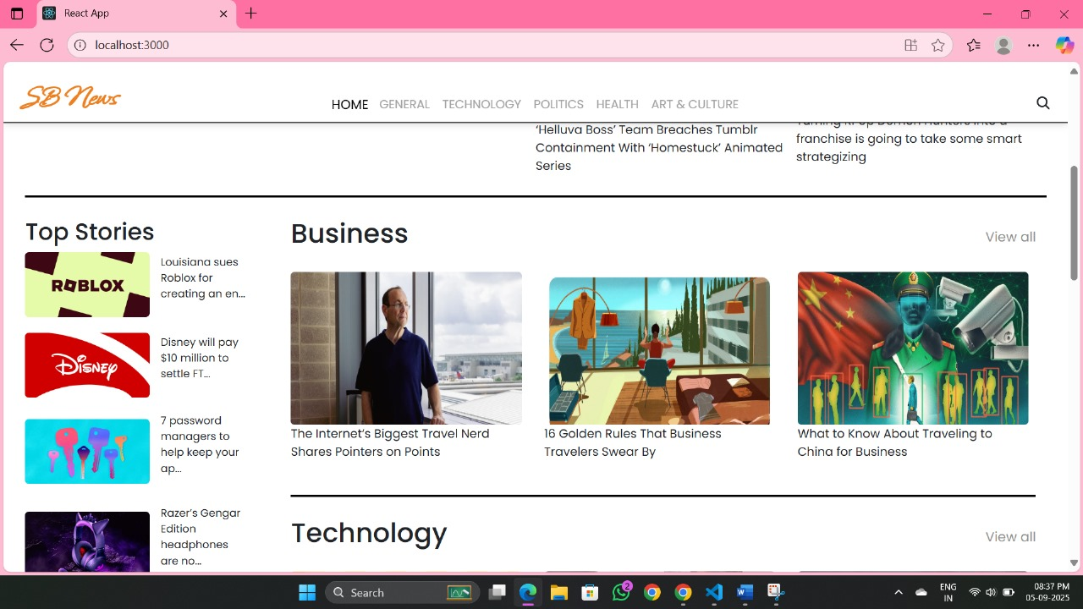

**12.KNOWN ISSUES**

Navigating the modern news landscape requires awareness of issues like the spread of misinformation, information overload, the financial struggles of traditional media, declining media literacy, and the impact of artificial intelligence (AI). Audiences face challenges distinguishing between factual reporting and opinion, verifying information, and managing the overwhelming volume of content. To navigate this landscape, users can employ strategies like checking information across multiple sources, understanding the difference between reporting and personal storytelling, and promoting media literacy programs in schools.

**13.FUTURE ENHANCEMENTS**

**Technological Transformations**

**Artificial Intelligence (AI):**

Generative AI is already used to create news articles, summaries, and visuals, transforming news production and personalizing content for individual users.

**Immersive Technologies (VR/AR):**

Virtual and augmented reality are emerging to offer new, immersive storytelling methods, transporting audiences to different times and places.

**5G Networks:**

The widespread implementation of 5G will enable new and faster forms of news delivery and more immersive experiences.

**Smart & Wearable Devices:**

News will be delivered directly to smart devices and wearables, making information more accessible and personalized

Changes in News Delivery & Consumption

**AI-Powered Search & Social Media Shift:**

Search engines are providing direct answers, and social media platforms are prioritizing their own content, leading to reduced traffic for news websites.

**Mobile-First Journalism:**

News will increasingly be consumed on mobile devices, necessitating mobile-optimized content and delivery methods.

The rise of social media and AI-generated content poses a challenge in distinguishing fact from fiction.